**Cognifyz Technologies Web Development Internship**

**Projects Report GitHub Repo Link:**

**Name: Noel Ninan Sheri**

**Ref. : CTI/A1/C131249**

Level 1 Task 1 Subtask 1: Source Code:

<!DOCTYPE html>

<html lang="en">

<head>

  <meta charset="UTF-8">

  <title>Simple Webpage</title>

  <style>

    *

    {

        font-family:Footlight MT Light;

    }

    body {

      text-align: center;

      padding: 40px;

      background-color: #f8f9fa;

    }

    h1 {

      color: #007bff;

    }

    p {

      font-size: 18px;

      margin: 20px 0;

    }

    img {

      width: 300px;

      height: auto;

      border-radius: 10px;

      box-shadow: 0 0 10px #ccc;

    }

  </style>

</head>

<body>

  <h1>Welcome to Cognifyz!</h1>

  <p>At Cognifyz Technologies, where data meets intelligence, we develop smart digital solutions that make an impact.</p>

  <img src="Cognifyz.png" alt="Cognifyz Image">

</body>

</html>

Output:

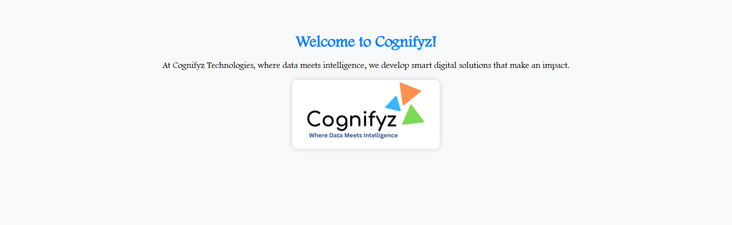

Level 1 Task 1 Subtask 2 Source Code:

<!DOCTYPE html>

<html lang="en">

<head>

  <meta charset="UTF-8">

  <title>Basic Form</title>

  <style>

    *

    {

        font-family:Footlight MT Light;

    }

    body {

      background-color: #f1f1f1;

      text-align: center;

      padding-top: 100px;

    }

    form {

      background-color: white;

      padding: 30px;

      display: inline-block;

      border-radius: 10px;

      box-shadow: 0 0 10px #ccc;

    }

    input[type="text"] {

      padding: 10px;

      font-size: 16px;

      width: 250px;

      margin-bottom: 15px;

    }

    button {

      padding: 10px 20px;

      font-size: 16px;

      background-color: #28a745;

      color: white;

      border: none;

      border-radius: 5px;

      cursor: pointer;

    }

  </style>

</head>

<body>

  <form>

    <h2>Enter Your Name</h2>

    <input type="text" placeholder="Your name here" required>

    <br>

    <button type="submit">Submit</button>

  </form>

</body>

</html>

Output:



Level 1 Task 1 Subtask 3 Source Code:

<!DOCTYPE html>

<html lang="en">

<head>

  <meta charset="UTF-8">

  <title>Navigation Menu</title>

  <style>

    *

    {

        font-family:Footlight MT Light;

    }

    body {

      margin: 0;

    }

    nav {

      background-color: #343a40;

      padding: 15px;

      text-align: center;

    }

    nav a {

      color: white;

      text-decoration: none;

      margin: 0 20px;

      font-size: 18px;

    }

    nav a:hover {

      text-decoration: underline;

    }

  </style>

</head>

<body>

  <nav>

    <a href="https://www.linkedin.com/in/noel-ninan-sheri/">LinkedInProfile</a>

    <a href="https://github.com/NoelNinanSheri1307">GitHub</a>

    <a href="www.noelninansheri@gmail.com">Contact</a>

  </nav>

</body>

</html>

Output:

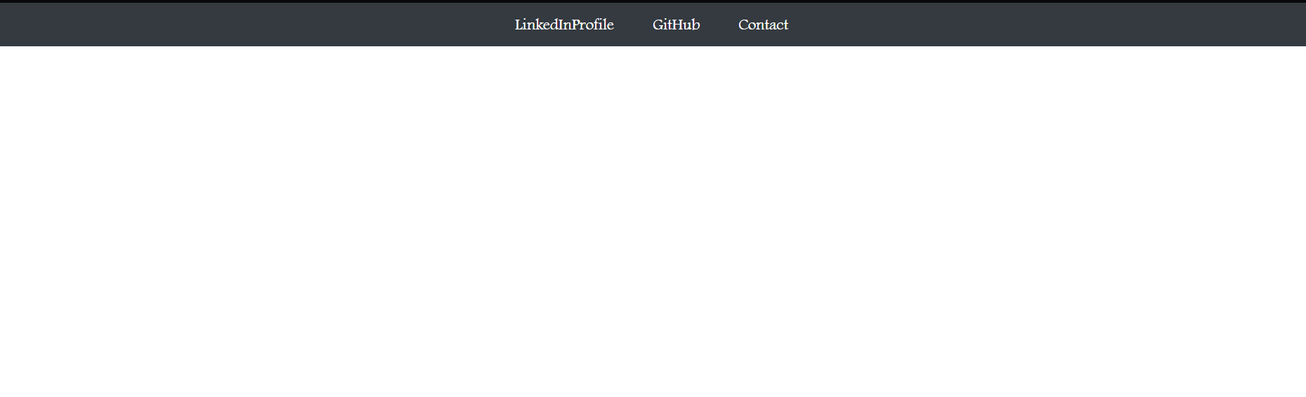

Level 2 Task1 Subtask 1 Source Code:

<!DOCTYPE html>

<html lang="en">

<head>

  <meta charset="UTF-8">

  <title>Color Change Button</title>

  <style>

    *

    {

        font-family:Footlight MT Light;

    }

    body {

      text-align: center;

      margin-top: 100px;

    }

    #colorButton {

      padding: 15px 30px;

      font-size: 18px;

      background-color: #007BFF;

      color: white;

      border: none;

      border-radius: 5px;

      cursor: pointer;

    }

    #colorButton.clicked {

      background-color: #28a745;

    }

  </style>

</head>

<body>

  <h2>Click the Button to Change Color</h2>

  <button id="colorButton" onclick="changeColor()">Click Me</button>

  <script>

    function changeColor() {

      const button = document.getElementById('colorButton');

      button.classList.toggle('clicked');

    }

  </script>

</body>

</html>

Output: Before Button is Clicked:

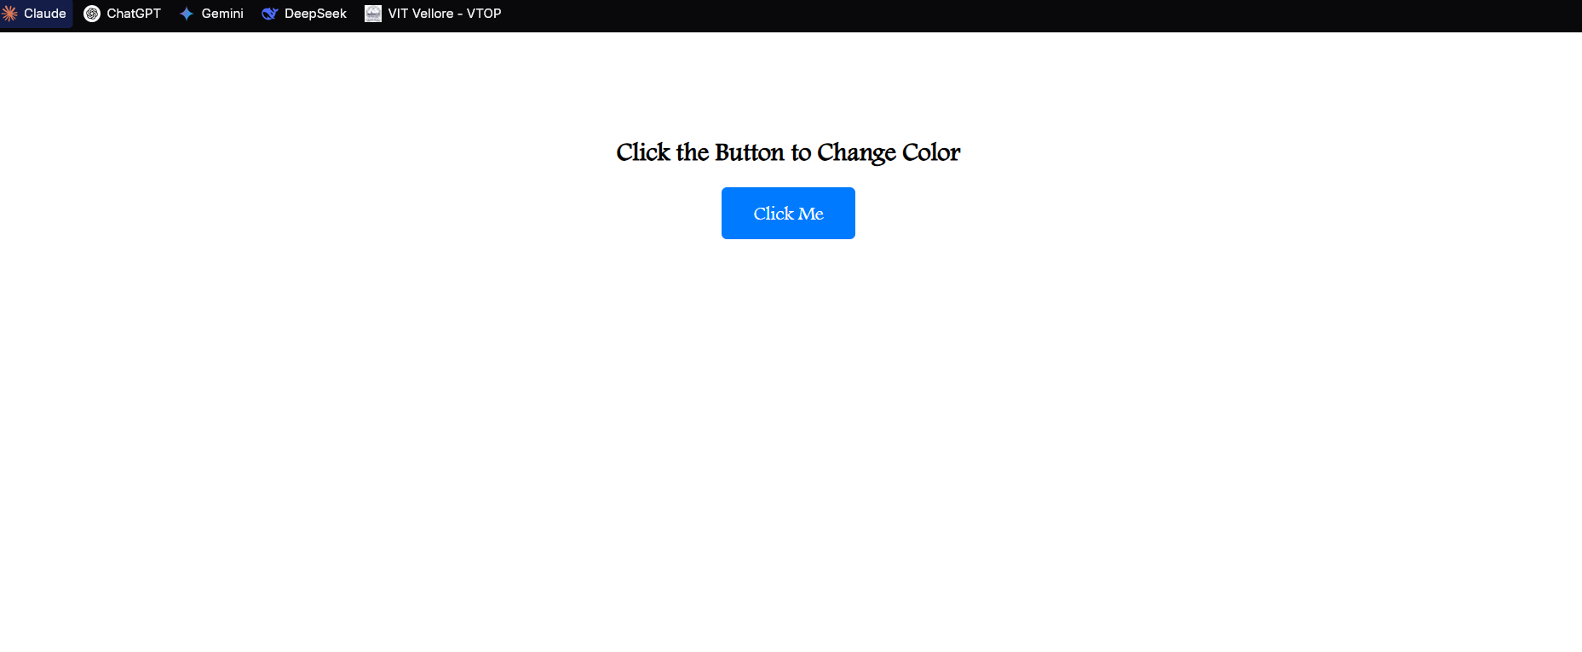

After Button is Clicked:

